Apple Cream Cheese Coffee Cake

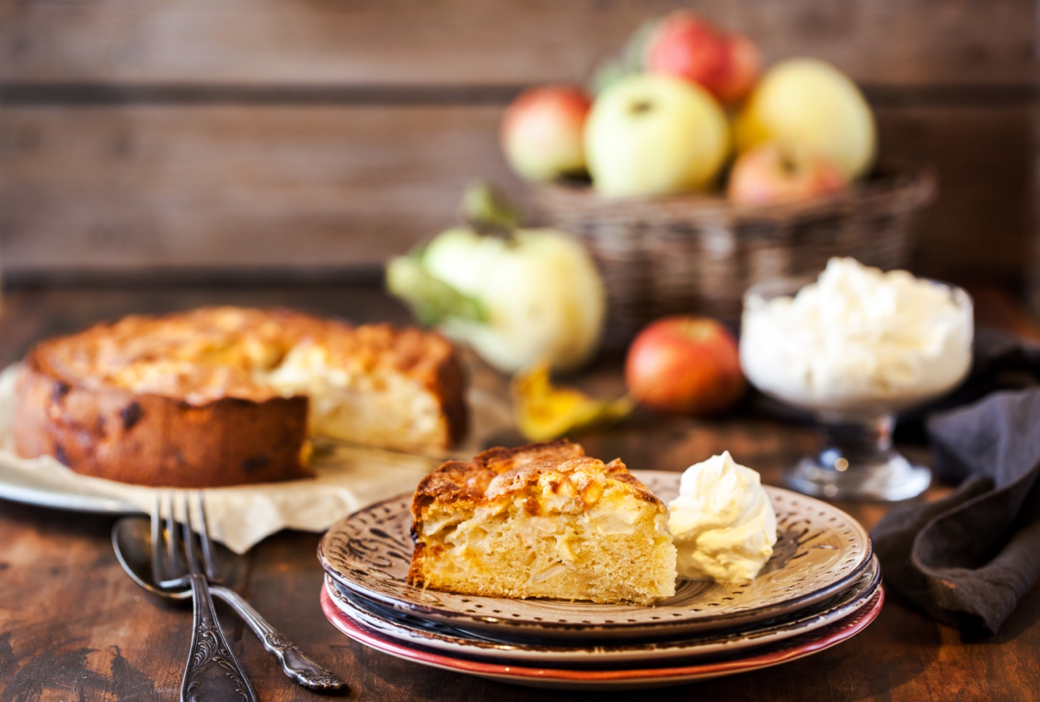

Base:
2 1/2 cups ROGERS NO ADDITVE/ALL PURPOSE FLOUR 625 mL
3/4 cup brown sugar 180 mL
3/4 cup butter 180 mL
1/2 tsp. baking powder 2 mL
1/2 tsp. baking soda 2 mL
1/2 tsp. salt 2 mL
3/4 cup plain yogurt 180 mL
2 eggs 2
1/2 tsp. vanilla 2 mL

For more information about our products and other recipes go to www.rogersfoods.com

Filling:
250g package cream cheese, softened 250g
1/2 cup sugar 125 mL
1/2 tsp. cinnamon 2 mL
1 egg 1
1/2 tsp. vanilla 2 mL
3 apples, peeled and sliced* 3
Topping:
1 cups ROGERS HAZELNUT & HONEY GRANOLA 250 mL
1/2 tsp. cinnamon 2 mL

Preheat oven to 350°F. Grease and flour 10” spring form pan.
In a large bowl, combine flour and brown sugar; cut in butter until mixture resembles coarse crumbs. Remove 1/2 cup of crumb mixture and set aside for topping.
To remaining crumb mixture, add baking powder, baking soda and salt; mix well. Stir together yogurt, eggs and vanilla in a separate bowl; add to dry ingredients and blend well. Spoon batter into pan. Flour hands well and spread batter evenly over the bottom and 2” up the sides of pan.
In a small bowl, combine cream cheese, sugar, cinnamon, egg and vanilla; blend well. Pour over base. Arrange apple slices on top.
Combine granola, cinnamon and reserved crumb mixture and sprinkle over apples.
Bake for 55-60 minutes or until cream cheese filling is set and apples are tender. Cool at least 15 minutes before removing sides of pan. Cool cake completely before serving. Cover and refrigerate leftovers.
*Use tart cooking apples for best flavour.
Yield: 16 servings.

For more information about our products and other recipes go to www.rogersfoods.com
For more information about our products and other recipes go to www.rogersfoods.com
For more information about our products and other recipes go to www.rogersfoods.com

